PROJECT REPORT ON

AUTOMATIC ROOM LIGHT INTENSITY

BASED

WINDOW

BLIND CONTROL SYSTEM



# DHARMSINH DESAI UNIVERSITY FACULTY OF TECHNOLOGY

DEPARTMENT OF ELECTRONICS & COMMUNICATION

## PREPARED BY: GUIDED BY:

Kush B. Patel Prof. Biren B. Patel

(Roll No.50), Sem. VI

CERTIFICATE

This is to certify that the project on **AUTOMATIC ROOM LIGHT INTENSITY BASED WINDOW BLIND CONTROL SYSTEM** and term work carried out in the subject of Term Project is bonafide work of **Kush B. Patel** (Roll no: **EC050**) of B. Tech. semester VI in the branch of **Electronics & Communication**, during the academic year 2020-21.

Prof. Biren B. Patel Dr. Purvang D. Dalal

Project Guide, EC Dept. HOD, EC Dept.

# ACKNOWLEDGEMENT

I express my sincere thanks and gratitude to Dr. Purvang Dalal (HOD) of EC Department

,Dharmsinh Desai University, Faculty Of Technology, Nadiad to arrange this project work for the students and provide me the opportunity to prepare the project and aggregate a wonderful memories and information in my portfolio.

I feel to acknowledge my deep sense of gratitude to Prof . Biren B..Patel who is our project supervisor.

# Abstract

* Typical mid income house-holds spend 1000-1500 Rs per month on electricity- 800 to 1000 kWh (kilowatts-hours). Most households could save 50 % to 70 % of this easily if we can use our technology and modern equipments and even more if we utilize the sunlight for lightening.
* In this project we have planned to develop an automatic blind control system in associate with outside sunlight to save the electricity. Whenever there is sunlight outside, blinds will be opened to utilize that light avoiding need of electricity. We can say that, opening of blinds is proportional to sunlight intensity.
* To control the blinds we planned to use stepper motor and intensity of sunlight is sensed using light dependent resistance (LDR) interfaced to on -chip ADC of Arduino. It takes input from sensor and then decides the opening of curtains and activates the motor through motor driver.

INDEX

|  |  |  |
| --- | --- | --- |
| **Sr. No.** | **Title** | **Page No.** |
| 1. | Introduction | 6 |
| 2. | Block Diagram | 6 |
| 3. | Circuit Diagram | 7 |
| 4. | Principle behind Automatic blind control system | 8 |
| 5. | Component Description (with pictures) | 9 |
| 6. | Working of Circuit | 10 |
| 7. | 7.1 Simulation results | 11 |
|  | 7.2 Description of simulation process | 12 |
| 8. | Limitations of Circuit | 14 |
| 9. | Conclusion | 14 |
| 10. | Application and Future work | 14 |
| 11. | Timeline | 15 |
| 12. | References | 16 |

# **1.INTRODUCTION**

The project basically revolves around the main aim of saving electricity. The project goes like if enough Sunlight is present outside then the curtains will get opened and room gets lightened.

1. BLOCK DIAGRAM

SUNLIGHT FALLS IN THE WINDOW

LDR

SLIDING WINDOWS CURTAINS

MOTOR

DRIVER

ARDUINO

### 

### Fig 2.1:Block Diagram of Automatic Room Light Intensity Control System

* + The block diagram of the Automatic Room Light Intensity Control system is shown in figure 2.1. The diagram consists of LDR , Arduino and Motor driver.

3.CIRCUIT DIAGRAM

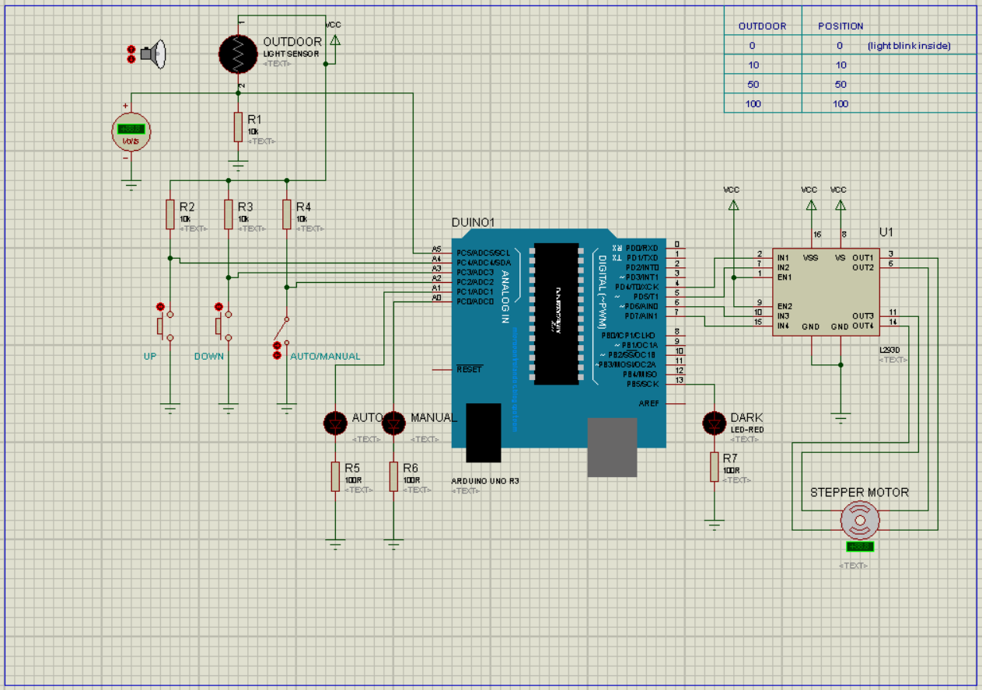

**Fig 3.1:Circuit Diagram of Automatic Room Light Intensity Control system**

1. Principle Behind Automatic Room Light Intensity Blind Control System**:**

* The aim of the project is to design such sliding windows using blind control system. It will be using the intensity of the sunlight.
* By providing the right amount of light.
* By providing that light when it is needed.

* So, whenever there is sunlight outside it will be opening according to it. So,we can say that intensity of light coming from the sun is proportional to opening of window. We have used LDR to automate the house. LDR used to control the window as open/close when sun lights falls on to the LDR. The basic concept of our automated system is that the position of the blinds is dependent on the intensity of light. Here, we have used Arduino.

## COMPONENT DESCRIPTION

|  |  |  |
| --- | --- | --- |
| **SERIAL NUMBER** | **COMPONENT TYPE** | **VALUE** |
| **1.** | **Light Dependent Resistor** | **NORPS-12** |
| **2.** | **Arduino** | **ATmega328** |
| **3.** | **MOTOR DRIVER** | **IC L293D** |
| **4.** | **STEPPER MOTOR** | **28BYJ-48** |

### Table 5.1.Components in table format

* **Light Dependent Resistor - NORPS-12**

• 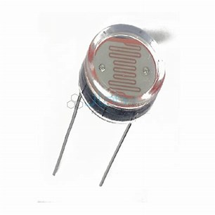

* **Arduino- ATmega328**

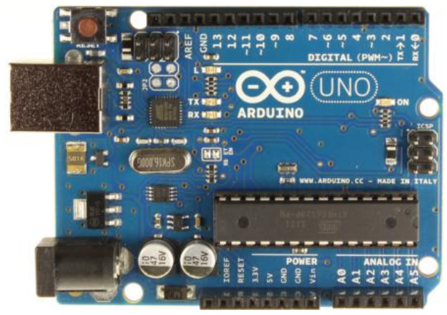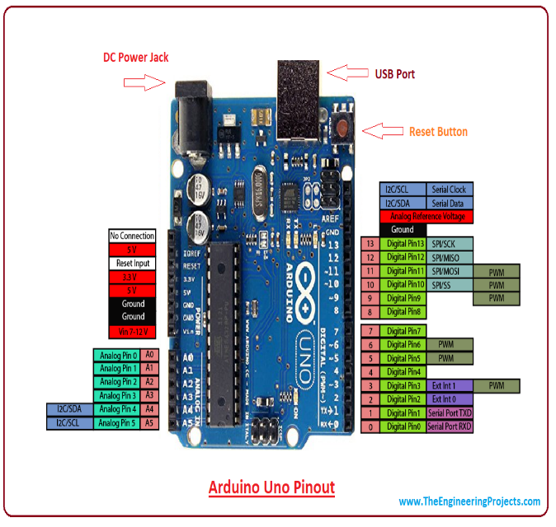

* **MOTOR DRIVER - IC L293D**

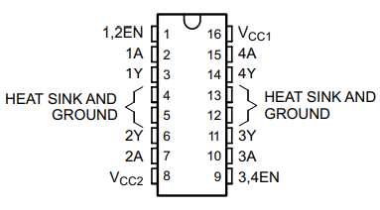

**STEPPER MOTOR - 28BYJ-48**

* 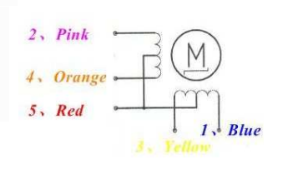

## 6 . WORKING OF CIRCUIT

* The above descripted setup of Automatic Room Light Intensity Based Window Blind Control System works on the principle of Light dependency. The procedure goes through the following way:
* The Sunlight outside is luminous and if its intensity is enough to light a room then the resistance of LDR (NORPS-12) on which the light is incident changes accordingly.
* As the resistance of the LDR changes accordingly a signal is also generated proportionally to the change in Resistance.
* The signal is then fed to the analog port of the Arduino.
* It further converts the signal to Digital form and then feeds to the Motor Driver.
* The Motor Driver feeds the respective signal to the Stepper Motor and it rotates and moves the curtains according to the luminance of the light outside.
* Another part is that we can move the curtain manually as well.
* A switch has been placed there that chooses which mode has to be applied.
* Two Push Buttons have been placed one for opening and other for closing the curtains.

## Simulation results:

## 

### Fig 7.1.Simulation video

.

## Description of simulation process:

Firstly , in the suitable environment where light is present we will keep the circuit on with Constant Power Supply. Now as you press on the automatic mode , the light will fall on the LDR sensor which changes the voltage drop across R1 , reducing the resistance and allowing the current to pass through. This signal is then fed to the motor driver pin which will then send the data to process further in the Controller. The Controller then decides the suitable amount of rotation steps for the motor on the basis of light intensity that was fed via the Ldr . If the intensity of light which is this case is an Led , As it Approaches Close Enough to the Ldr The rotation will be resulting in the opening of the Blinds , and it it goes farther away this will result in the opposite direction of rotation hence resulting in closing of the blinds . Incase not enough light being fed to sensor we have set another switch which will allow to manually control the blinds which will directly allow the switches Up and Down to be functional and the Respected Lights will light up informing which mode is being used currently.

The code is mentioned here :

#define up A4

#define down A3

#define automanual A2

#define ledAuto A1

#define ledManual A0

#define led 13

#include <Stepper.h>

int previous = 0;

int val = 0;

const int stepsPerRevolution = 200;

Stepper myStepper(stepsPerRevolution, 4, 5, 6, 7);

void setup() {

myStepper.setSpeed(5);

pinMode(up,INPUT);

pinMode(down,INPUT);

pinMode(automanual,INPUT);

pinMode(ledAuto,OUTPUT);

pinMode(ledManual,OUTPUT);

pinMode(led,OUTPUT);

Serial.begin(9600);

}

void loop() {

// step one revolution in one direction:

if(digitalRead(automanual)==LOW){

digitalWrite(ledManual,HIGH);

digitalWrite(ledAuto,LOW);

digitalWrite(led,LOW);

if(digitalRead(up)==LOW){

myStepper.step(1);

while(digitalRead(up)==LOW);

delay(100);

}

else if(digitalRead(down)==LOW){

myStepper.step(-1);

while(digitalRead(down)==LOW);

delay(100);

}

**}**

else{

digitalWrite(ledManual,LOW);

digitalWrite(ledAuto,HIGH);

val = (analogRead(5)/20);

if(val<5){

digitalWrite(led,(!digitalRead(led)));

delay(500);

}

else{

digitalWrite(led,LOW);

}

myStepper.step(val - previous);

previous = val;

}

}

## LIMITATIONS OF CIRCUIT AND FUTURE WORK

* + We can use the IOT(Internet of things) in future.
  + It requires a lot of frequency setting.
  + We can use this blind control system for more than one window.

## 9.CONCLUSION

* + - This project presents an Automatic Room light intensity based on window blind control system which can detect the intensity of sunlight and to control the window as open/close when sun lights falls on to the LDR. I have concluded that the window opens according to the sunlight intensity. The results are perfectly upto the mark , it works as window blind control system.

## APPLICATION

* + Used in Homes and Offices.
  + To use the solar form of energy.
  + To use the renewable enegy and convert into the mechanical energy.

## Timeline:

|  |  |
| --- | --- |
| **WEEK** | **WORK DONE** |
| 1. | Project Definition |
| 2. | Sensor Specification and Working |
| 3. | Verification of Sensor and Assortment of Microcontroller |
| 4. | Program Design Flow |
| 5. | Circuit Diagram |
| 6. | Selection of required peripherals of Microcontroller |
| 7. | Implementation of Circuit in Proteus and Market Survey |
| 8. | Coding in Arduino |
| 9. | Debugging of Arduino Code |
| 10. | Documentation |
| 11. | Energy Calculations and Comparisons among different Motors |
| 12. | Final Report |

1. References
   * [Automatic room light intensity based window blinds control system (slideshare.net)](https://www.slideshare.net/Ecwayt/automatic-room-light-intensity-based-window-blinds-control-system)
   * https://www.elprocus.com/know-about-working-of-automatic-room-light...